University of the Cumberlands
Week 6 Final Research Paper
Chaitanya Boyapati

Abstract
Reference Model for Service Oriented Architecture is an abstract framework for
understanding significant entities and relationships between them within a serviceoriented environment, and for the development of consistent standards or specifications
supporting that environment. A reference model in systems, enterprise, and software engineering is an abstract framework or domain-specific ontology consisting of an interlinked set of clearly defined concepts produced by an expert or body of experts in order to encourage clear communication. A reference model can represent the component parts of any consistent idea, from business functions to system components, as long as it represents a complete set. This frame of reference can then be used to communicate ideas clearly among members of the same community. It is based on unifying concepts of SOA and may be used by architects developing specific service oriented architectures or in training andexplaining SOA. A reference model is not directly tied to any standards, technologies or other concrete implementation details. It does seek to provide a common semantics that can be used unambiguously across and between different implementations. The reference model is intended to provide an even higher level of commonality, with 7 definitions that should apply to all SOA.

Introduction :
The EDRM.net Information Governance Reference Model (IGRM) depicts a framework for
unified information governance by an organization’s leadership and key stakeholders.
The IGRM supports ARMA International’s GARP® Principles1
by identifying the cross-functional groups of key information governance stakeholders and by depicting their intersecting objectives for the organization. This illustration of the relationship between duty, value and the information asset demonstrates cooperation among stakeholder groups to achieve the desired level of maturity of effective information governance.
There are many uses for a reference model. One use is to create standards for both the objects that inhabit the model and their relationships to one another. By creating standards, the work of engineers and developers who need to create objects that behave according to the standard is made easier. Software can be written that meets a standard, and developers can copy that software to use it again, or build a software factory that generates that code. When done well, a standard can make use of design patterns that support key qualities of software, such as the ability to extend the software in an inexpensive way.
Another use of a reference model is to educate. Using a reference model, leaders in software development can help break down a large problem space into smaller problems that can be understood, tackled, and refined. Developers who are new to a particular set of problems can quickly learn what the different problems are, and can focus on the problems that they are being asked to solve, while trusting that other areas are well understood and rigorously constructed.
Reference Model for Service Oriented:
The goal of this reference model is to define the essence of service oriented architecture, and
emerge with a vocabulary and a common understanding of SOA. It provides a normative reference that remains relevant for SOA as an abstract and powerful model, irrespective of the various and inevitable technology evolutions that will influence SOA deployment.
A reference model for SOA relates to other distributed systems architectural inputs. The concepts and relationships defined by the reference model are intended to be the basis for describing references architectures and patterns that will define more specific categories of SOA designs. Concrete architectures arise from a combination of reference architectures, architectural patterns and additional requirements, including those imposed by technology environments. Architecture must account for the goals, motivation, and requirements that define the actual problems being addressed. While reference architectures can form the basis of classes of solutions, concrete architectures will define specific solution approaches. Architecture is often developed in the context of a pre-defined environment, such as the protocols, profiles, specifications, and standards that are pertinent. SOA implementations combine all of these elements, from the more generic architectural principles and infrastructure to the specifics that define the current needs, and represent specific implementations that will be built and used in an operational environment.
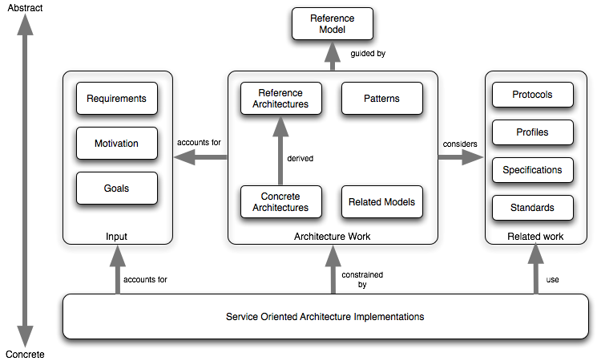
Service Oriented Architecture (SOA) is a paradigm for organizing and utilizing distributed capabilities that may be under the control of different ownership domains. In general, entities (people and organizations) create capabilities to solve or support a solution for the problems they face in the course of their business. It is natural to think of one person’s needs being met by capabilities offered by someone else; or, in the world of distributed computing, one computer agent’s requirements being met by a computer agent belonging to a different owner. There is not necessarily a one-to-one correlation between needs and capabilities; the granularity of needs and capabilities vary from fundamental to complex, and any given need may require the combining of numerous capabilities while any single capability may address more than one need. The perceived value of SOA is that it provides a powerful framework for matching needs and capabilities and for combining capabilities to address those needs. Visibility, interaction, and effect are key concepts for describing the SOA paradigm. Visibility refers to the capacity for those with needs and those with capabilities to be able to see each other. This is typically done by providing descriptions for such aspects as functions and technical requirements, related constraints and policies, and mechanisms for access or response.
The purpose of using a capability is to realize one or more real world effects. At its core, an interaction is “an act” as opposed to “an object” and the result of an interaction is an effect (or a set/series of effects). This effect may be the return of information or the change in the state of entities (known or unknown) that are involved in the interaction. We are careful to distinguish between public actions and private actions.
This description of SOA has yet to mention what is usually considered the central concept: the service. The noun “service” is defined in dictionaries as “The performance of work (a function) by one for another.” However, service, as the term is generally understood, also combines the following related ideas:
• The capability to perform work for another
• The specification of the work offered for another
• The offer to perform work for another soa concepts emphasize a distinction between a capability and the ability to bring that capability to bear. While both needs and capabilities exist independently of SOA, in SOA, services are the mechanism by which needs and capabilities are brought together. SOA is a means of organizing solutions that promotes reuse, growth and interoperability. It is not itself a solution to domain problems but rather an organizing and delivery paradigm that enables one to get more value from use both of capabilities which are locally “owned” and those under the control of others. It also enables one to express solutions in a way that makes it easier to modify or evolve the identified solution or to try alternate solutions. SOA does not provide any domain elements of a solution that do not exist without SOA.

These concepts emphasize a distinction between a capability and the ability to bring that capability to bear. While both needs and capabilities exist independently of SOA, in SOA, services are the mechanism by which needs and capabilities are brought together. SOA is a means of organizing solutions that promotes reuse, growth and interoperability. It is not itself a solution to domain problems but rather an organizing and delivery paradigm that enables one to get more value from use both of capabilities which are locally “owned” and those under the control of others. It also enables one to express solutions in a way that makes it easier to modify or evolve the identified solution or to try alternate solutions. SOA does not provide any domain elements of a solution that do not exist without SOA. Note that while an SOA service brings together needs and capabilities, the provider of the underlying capability may not be the same entity that eventually provides the service which accesses that capability. In reality, the entity with the domain expertise to create, maintain, and evolve a given capability may not have the expertise or the desire to create, maintain, and evolve its service access. The concepts of visibility, interaction, and effect apply directly to services in the same manner as these were described for the general SOA paradigm. Visibility is promoted through the service description which contains the information necessary to interact with the service and describes this in such terms as the service inputs, outputs, and associated semantics. The service description also conveys what is accomplished when the service is invoked and the conditions for using the service.
Principle concepts of Reference Model:
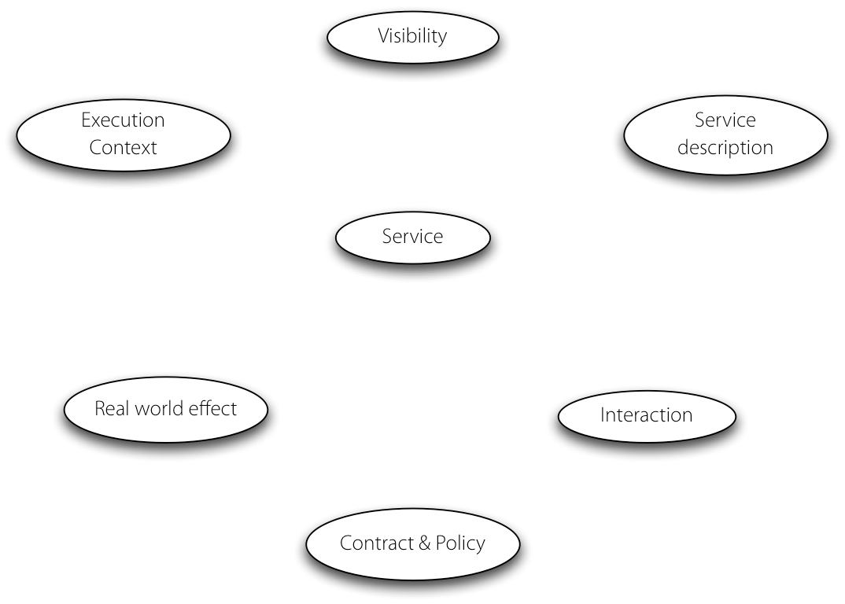

Service:
A service is a mechanism to enable access to one or more capabilities, where the access is provided using a prescribed interface and is exercised consistent with constraints and policies as specified by the service description. A service is provided by an entity – the service provider for use by others, but the eventual consumers of the service may not be known to the service provider and may demonstrate uses of the service beyond the scope originally where the interface comprises the specifics of how to access the underlying capabilities. There are no constraints on the service could carry out its described functionality through one or more automated and/or manual processes that themselves could invoke other available services. A service is opaque in that its implementation is typically hidden from the service consumer for the information and behavior models exposed through the service interface and the information required by service consumers to determine whether a given service is appropriate for their needs.

Visibility:
A service provider and consumer to interact with each other they have to be able to ‘see’ each other. This is true for any consumer/provider relationship – including in an application program where one program calls another: without the proper libraries being present the function call cannot complete. In the case of SOA, visibility needs to be emphasized because it is not necessarily obvious how service participants can see each other.Visibility is the relationship between service consumers and providers that is satisfied when they are able to interact with each other. Preconditions to visibility are awareness, willingness and reachability. The initiator in a service interaction MUST be aware of the other parties, the participants MUST be predisposed to interaction, and the participants MUST be able to interact.
Service description:
The service description represents the information needed in order to use as service. In most cases, there is no one “right” description but rather the elements of description required depend on the context and the needs of the parties using the associated entity. While there are certain elements that are likely to be part of any service description, most notably the information model, many elements such as function and policy may vary. The purpose of description is to facilitate interaction and visibility, particularly when the participants are in different ownership domains, between participants in service interactions. By providing descriptions, it makes it possible for potential participants to construct systems that use of services and even offer compatible services.
Execution context:
The execution context of a service interaction is the set of infrastructure elements, process entities, policy assertions and agreements that are identified as part of an instantiated service interaction, and thus forms a path between those with needs and those with capabilities. As discussed in previous sections of this document, the service description (and a corresponding description associated with the service consumer and its needs) contains information that can include preferred protocols, semantics, policies and other conditions and assumptions that all Rights Reserved. The participants (providers, consumers, and any third parties as noted below) must agree and acknowledge a consistent set of agreements in order to have a successful service interaction, i.e. realizing the described real world effects. The execution context is the collection of this consistent set of agreements.
The execution context is not limited to one side of the interaction; rather it concerns the totality of the interaction – including the service provider, the service consumer and the common infrastructure needed to mediate the interaction. While there may be third parties, for example, government regulators, who set some of the conditions for the execution context, this merely increases the conditions and constraints needing to be coordinated and may require additional information exchange to complete the execution context.
The execution context is central to many aspects of a service interaction. It defines, for example, a decision point for policy enforcement relating to the service interaction. Note that a policy decision point is not necessarily the same as an enforcement point: an execution context is not by itself something that lends itself to enforcement. On the other hand, any enforcement mechanism of a policy is likely to take into account the particulars of the actual execution context. The execution context also allows us to distinguish services from one another. Different instances of the same service – denoting interactions between a given service provider and different service consumers for example – are distinguished by virtue of the fact that their execution contexts are different. Finally, the execution context is also the context in which the interpretation of data that is exchanged takes place. A particular string has a particular meaning in a service interaction in a particular context – the execution context.

Contract and Policies:
A policy represents some constraint or condition on the use, deployment or description of an owned entity as defined by any participant. A contract, on the other hand, represents an agreement by two or more parties. Like policies, agreements are also about the conditions of use of a service; they may also constrain the expected real world effects of using a service. The reference model is focused primarily on the concept of policies and contracts as they apply to services. We are not concerned with the form or expressiveness of any language used to express policies and contracts.

Benefits of Service Oriented Architecture In Information Governance:
The main drivers for SOA-based architectures are to facilitate the manageable growth of large scale enterprise systems, to facilitate Internet-scale provisioning and use of services and to reduce costs in organization to organization cooperation. The value of SOA is that it provides a simple scalable paradigm for organizing large networks of systems that require interoperability to realize the value inherent in the individual components. Indeed, SOA is scalable because it makes the fewest possible assumptions about the network and also minimizes any trust assumptions that are often implicitly made in smaller scale systems. An architect using SOA principles is better equipped, therefore, to develop systems that are scalable, evolvable and manageable. It should be easier to decide how to integrate functionality across ownership boundaries. For example, a large company that acquires a smaller company must determine how to integrate the acquired IT infrastructure into its overall IT portfolio. Through this inherent ability to scale and evolve, SOA enables an IT portfolio which is also adaptable to the varied needs of a specific problem domain or process architecture. The infrastructure SOA encourages is also more agile and responsive than one built on an exponential number of pair-wise interfaces. Therefore, SOA can also provide a solid foundation for business agility and adaptability.

Conclusion:
While the IGRM is broad in focus, it illustrates key responsibilities and interdependencies of information stakeholders in an organization. As such, the IGRM complements the metrics defined by ARMA International’s Information Governance Maturity Model.
• The IGRM is a powerful communication tool that promotes cross-functional dialogue and collaboration among stakeholder groups within an organization pursuing higher levels of information governance.
• The IGRM illustrates the relationship of key stakeholders (BUSINESS, IT, RIM, LEGAL) to each other – and to the Information Lifecycle.
• An organization’s continuously improved recordkeeping can be positively transformative and lead to increased profitability. Fundamentally, information governance is a business process. In order to lower risks and achieve greater efficiencies through process improvement, electronic discovery will increasingly become tightly integrated with an organization’s information governance policy, procedures, and infrastructure.

References
1. S. Bradner, Key words for use in RFCs to Indicate Requirement Levels, 782 http://www.ietf.org/rfc/rfc2119.txt, IETF RFC 2119, March 1997.

2. Y. Chen, P. Martin, H. Schentz, B. Magagna, Z. Zhao, A. Hardisty, A. Preece, M. Atkinson http://envri.eu/rm

